Bitcoin Bowl 1

I made this in December of 2013.

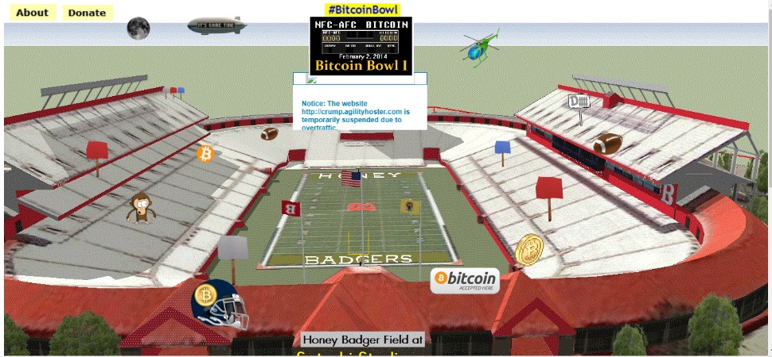

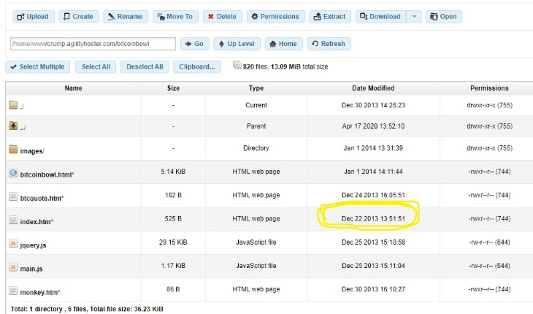

My thought was to do like the million dollar web page. I got nothing from it, but it’s cool and still has potential.

There was a Bitcoin Bowl shortly after in St. Petersburg, FL, which was neat.